Quiz 1

In the Hypothetical Machine the contents of memory was as shown. And PC contents is 300. Show the contents of memory and PC , AC , IR after execute three instructions (three fetch cycle and there execute cycle)

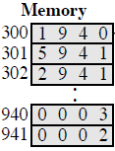Nermin Ezzat

Answer:-

FETCH EXECUT

|  |  |
| --- | --- |
| AC : 0000  IR : 1940 PC : 300  ----------------------------------------------------------  940 :0003  941 :0002 | AC : 0003  IR : 1940 PC : 300  ----------------------------------------------------------  940 :0003  941 :0002 |
| AC : 0003  IR : 5941 PC : 301  ----------------------------------------------------------  940 :0003  941 :0002 | AC:0005  IR: 5941 PC:301  ----------------------------------------------------------  940:0003  941:0002 |
| AC : 0005  IR : 2941 PC : 302  ----------------------------------------------------------  940 :0003  941 :0002 | AC : 0000  IR : 2941 PC : 302  ----------------------------------------------------------  940 :0003  941 :0005 |

Show the contents of PC , AC and IR and memory after the execution of each instruction of the following program on the Hypothetical Machine:

300 LOAD 550

301 ADD 551

302 STORE 600

Answer:-

FETCH EXECUT

|  |  |
| --- | --- |
| AC : 0000  IR : 1550 PC : 300  ----------------------------------------------------------  550 :0003  551 :0004  600 :0000 | AC : 0003  IR : 1550 PC : 300  ----------------------------------------------------------  550 :0003  551 :0004  600 :0000 |
| AC : 0003  IR : 5551 PC : 301  ----------------------------------------------------------  550 :0003  551 :0004  600 :0000 | AC : 0007  IR : 5551 PC : 301  ----------------------------------------------------------  550 :0003  551 :0004  600 :0000 |
| AC : 0007  IR : 2600 PC : 302  ----------------------------------------------------------  550 :0003  551 :0004  600 :0000 | AC : 0000  IR : 2600 PC : 302  ----------------------------------------------------------  550 :0003  551 :0004  600 :0007 |

Where the contents of memory at 550 is 3 and at 551 is 4.

The following figure provide the main characteristics of Hypothetical Machine.

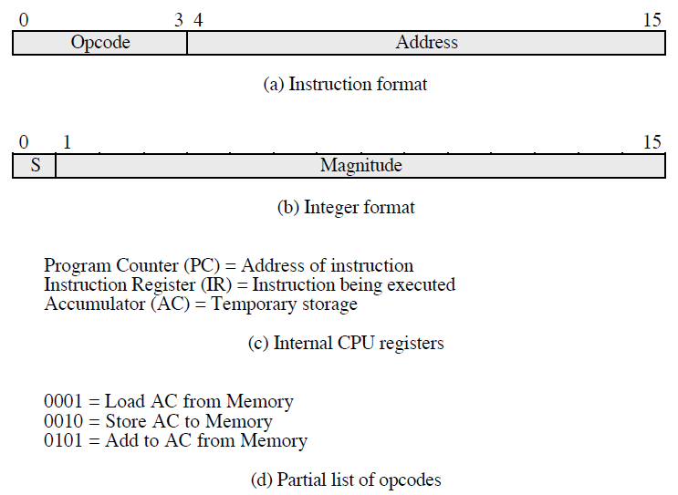

The hypothetical machine also has two I/O instructions:

0011 = load AC from I/O

0111 =store AC to I/O

In these case, the 12-bi address identifies a particular I/O device. Show the program execution for the following program:

1. Load AC from device 5.

2. Add contents of memory location 940.

3. Store AC to device 6.

Assume that the next value retrieved from device 5 is 3 and that location 940 contains a value of 2.

Answer:-

|  |  |
| --- | --- |
| **MEMORY** | |
| **300** | **3005** |
| **301** | **5940** |
| **302** | **7006** |

**THIRD ITERATION :-**

* device 5: 0003
* 940: 2
* device 6: 0005